Transportation Management System
Course: Database Systems

Table of Contents
- Phase 1 overview
- System Overview
- Database Design
- Implementation Details
- Challenges & Solutions
- 6. Conclusion

Requirments:
Functional:
1️) User Management
• Register new users (passengers or drivers) with personal details.
• Log in and authenticate users securely.
• Allow users to update their profile and password.
• The system shall differentiate between normal users and drivers
2️) Driver Management
• Register drivers with license and national ID.
• Assign vehicles to drivers (with assignment dates).
• Allow assigning multiple vehicles to 1 driver
• Track driver status (active/inactive).
3) Vehicle Management
• Register new vehicles (type, model, plate, year).
• Link vehicles to drivers through historical or current assignments.
• The system shall maintain a history of vehicles used by each driver.
4) Ride Management
• Allow users to request a ride by providing start and end locations.
• Match drivers to ride requests.
• Record ride details: time, date, fee, payment method.
• The system shall allow applying promo codes to rides, modifying the ride fee based on discount percentage.
• The system shall allow drivers to view the list of rides they have performed.
• The system shall automatically assign the nearest available driver to a user’s ride request.
5) Ratings & Feedback
• Allow users and drivers to rate and comment on rides.
• Store and calculate average user and driver ratings.
6) Promo Code Management
• Create and manage promo codes with discount percentage, expiry, and max usage.
• Apply promo codes to rides if valid.
• The system shall prevent users from applying expired promo codes.
7) Reporting & Analytics
• Track ride demand by area.
• Identify top drivers by ride count.
• Analyze vehicle usage by type.
• Monitor driver performance by ratings.
• Identify inactive drivers or vehicles.

Non-Functional Requirements:
1️) Performance
• The system should handle high volumes of ride requests and queries without significant delays.
• Reports (e.g., top drivers, most used vehicles) should generate within seconds.
2️) Scalability
• The system must support scaling to thousands of users, drivers, and rides as the businessgrows.
3️) Security
• User passwords must be securely stored (e.g., hashed).
• Personal data (e.g., phone numbers, national IDs) must be protected against unauthorized access.
4️) Reliability
• The system should have high uptime and ensure no data loss (especially for rides and payments).
5️) Maintainability
• The system code and database should be modular and well-documented to allow future updates (e.g., adding new vehicle types).
6️) Availability
• The system should be available 24/7 for users to book rides and for drivers to accept them.
7️) Data Integrity
• Ensure consistency between related tables (e.g., no orphan rides without drivers).
• Foreign key constraints and validations must be enforced.
8️) Usability
• The system interfaces (web/app) must be user-friendly for both passengers and drivers.
• Clear error messages and guidance for issues like invalid promo codes.

2. Introduction
This project aims to develop a Transportation Management System, inspired by popular ride-hailing services like Uber. The goal is to build a desktop application that facilitates ride booking, vehicle management, and promo code application using a robust database structure.
Objectives:
- Register users and drivers with relevant personal and vehicle details.
- Allow users to book rides based on location and vehicle type.
- Implement secure login functionality.
- Manage promotional discounts via promo codes.
- Maintain a clean, functional GUI with Windows Forms.
Technologies Used:
- Programming Language: C#
- Framework: .NET Framework 4.7.2
- Database: SQL Server

- GUI Framework: Windows Forms
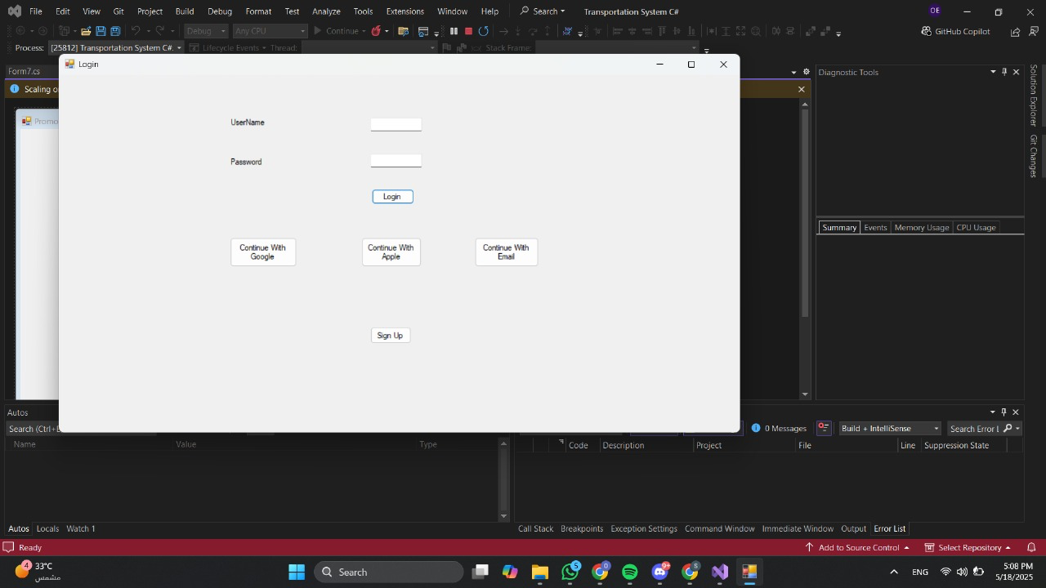

2. System Overview
User Registration:
- Collects full name, email, password, address, and gender.
- Drivers are required to register vehicle type and model.
- Input validation includes password confirmation and selection via radio buttons.
Login:
- Authenticates credentials from the database.
- Grants access to the ride booking interface upon success.
Ride Booking:
- Allows users to search for available rides based on their location (Class1.from_where) and preferred vehicle type.
- Filters and displays driver and vehicle data using dataGridView1.
Promo Code Management:
- Admins can add or delete promo codes.
- Promo codes apply discounts during ride checkout.

2. Database Design
Schema Overview
Tables:
- Users: UserID, FullName, Email, Password, Address, Gender
- Drivers: DriverID, UserID (foreign key)
- Vehicles: VehicleID, VehicleType, VehicleModel
- DriverVehicles: Maps drivers to their vehicles

ER Diagram: 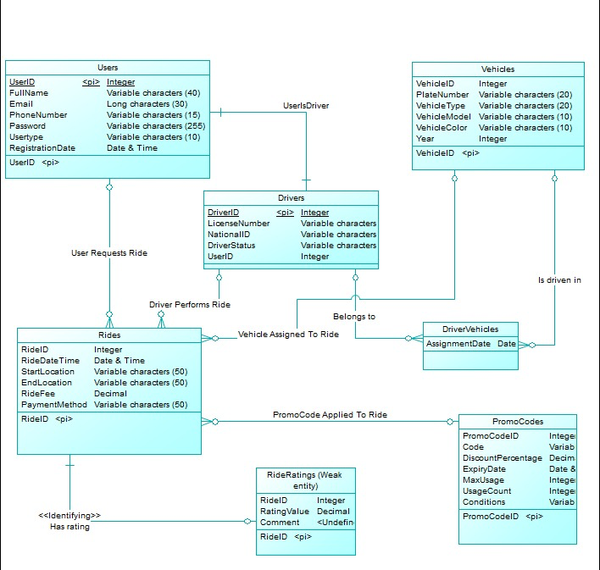
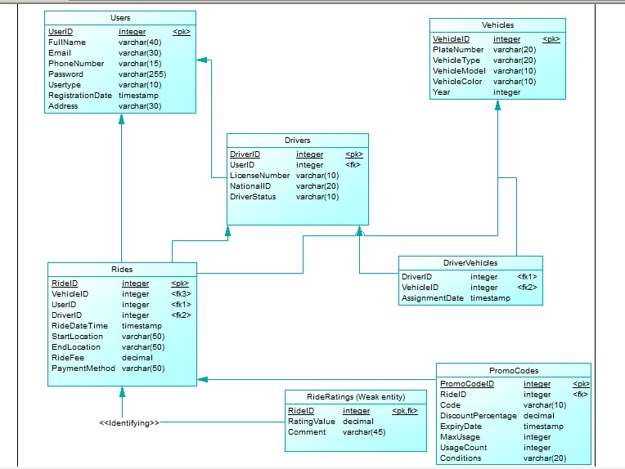
Sample SQL Query:
A)
SELECT PickupLocation, COUNT(*) AS RideCount
FROM Rides
WHERE MONTH(RideTime) = MONTH(CURDATE() - INTERVAL 1 MONTH)
AND YEAR(RideTime) = YEAR(CURDATE() - INTERVAL 1 MONTH)
GROUP BY PickupLocation
ORDER BY RideCount DESC;
B)
SELECT d.DriverID, u.Name, COUNT(*) AS RideCount
FROM Rides r
JOIN Drivers d ON r.DriverID = d.DriverID
JOIN Users u ON d.DriverID = u.UserID
WHERE MONTH(RideTime) = MONTH(CURDATE() - INTERVAL 1 MONTH)
AND YEAR(RideTime) = YEAR(CURDATE() - INTERVAL 1 MONTH)
GROUP BY d.DriverID
ORDER BY RideCount DESC
LIMIT 1;
C)
SELECT d.DriverID, u.Name, u.Email, u.Phone, d.LicenseNumber, COUNT(r.RideID) AS RideCount
FROM Drivers d
JOIN Users u ON d.DriverID = u.UserID
LEFT JOIN Rides r ON d.DriverID = r.DriverID
GROUP BY d.DriverID;
D)
SELECT d.DriverID, u.Name
FROM Drivers d
JOIN Users u ON d.DriverID = u.UserID
WHERE NOT EXISTS (
SELECT 1
FROM Rides r
JOIN Ratings rt ON r.RideID = rt.RideID
WHERE r.DriverID = d.DriverID AND rt.Rating < 4.5
);
E)
SELECT d.DriverID, u.Name
FROM Drivers d
JOIN Users u ON d.DriverID = u.UserID
WHERE d.DriverID NOT IN (
SELECT DriverID
FROM Rides
WHERE MONTH(RideTime) = MONTH(CURDATE() - INTERVAL 1 MONTH)
AND YEAR(RideTime) = YEAR(CURDATE() - INTERVAL 1 MONTH)
);
F)
SELECT v.Type, COUNT(*) AS RideCount
FROM Rides r
JOIN Drivers d ON r.DriverID = d.DriverID
JOIN Vehicles v ON d.VehicleID = v.VehicleID
WHERE MONTH(RideTime) = MONTH(CURDATE() - INTERVAL 1 MONTH)
AND YEAR(RideTime) = YEAR(CURDATE() - INTERVAL 1 MONTH)
GROUP BY v.Type
ORDER BY RideCount DESC
LIMIT 1;

5. implementation details
Database Connection (C#):
private SqlConnection con = new SqlConnection(@"Data Source=OMARELWAY;Initial Catalog=Uber;Integrated Security=True");
Login Navigation (C#):
private void login_button_Click(object sender, EventArgs e) {
Form3 form3 = new Form3();
form3.Show();
this.Hide();
}
Session Data Storage:
Class1.cs is used to store session-level variables:
- Class1.from_where: Represents user's selected location.
- Class1.selectedDriver: Stores selected driver’s ID for the ride.

6. Challenges & Solutions
Challenge | Solution
Complex table relationships | Resolved using SQL JOINs and foreign key constraints.
Input validation on forms | Used radio buttons and conditional checks for accurate input capture.
Sharing data between forms | Utilized static variables in Class1.cs for consistent session handling.

7. Conclusion
This Transportation Management System successfully implements the foundational features of a ride-booking platform:
- Separate user and driver flows.
- Functional login and ride booking system.
- Promo code application and management.
Future Improvements:
- Integrate payment gateways for checkout.
- Add real-time vehicle tracking.
- Encrypt stored passwords for better security.

